**Chapter IV**

**PRESENTATION, ANALYSIS AND INTERPRETATION**

This chapter will discuss the presentation, analysis, and interpretation of data corresponding to the research study stated at the beginning of the study. All the graphs, studies and other data that provides the study to strengthen the ideas below.

**4.1 Developing the Existing System to the Proposed System**

**Context Diagram of the Proposed System**

The proposed system has 3 users: First, administrator for the distributing, monitoring the reports and transaction. Secondly, customers for the ordering, transaction, and contacting the developers. Lastly, agent for the updating of the product if they have a new product, and they can monitor the product and the order of the customer. The system can enhance in terms of payment, geographical location of the customer, less security provision and the accurateness of the product management. The diagram below shows the context diagram of the proposed system.



*Figure 4.1: Context Diagram of the Proposed System*

1. The file management system that can handle the uploaded files or documents of the user.

In all accounts, the image uploaded directly to the specific folder on our server, the image file name uploaded to the one of the column on our database and also the information inputted of all account type uploaded to our database. In different account type, they only see what the account type only need to see. They can create, update and even delete but not on our database but on user interface only, we do this feature because we believed all data is very important and maybe they or we need it for future information.

1. It can maintain and secure the files, product and transaction of the client.

We used the CodeIgniter for building this site, a framework of PHP. It’s secure on common exploitations like SQL injection, and XSS (Cross Site Scripting). Also, it has a security for the path location or controller and the product for accessing, they can’t access it unless they have the permission on it. In the transaction of the client, they can sure their transaction is safe because PayPal have a protection to its buyers and sellers, they have a 24/7 monitoring.

1. The helps of having different modules are to organized the tasks, actions, and needs in all modules. It helps to fasten up the transaction and transportation of information to specific modules.
2. The clients and customer can pay their purchased template or product by clicking the rent this site and fill up all information needed and just click buy now to proceed to the PayPal payment site, they pay using their account on PayPal or choosing the pay with debit or credit card button and filling up all the information needed and after that they redirect to the success page on our website.
3. It’s secured and safe for the money transaction to those unethical hackers because we used PayPal as payment method, and the user doesn’t need to input their bank account on our site.
4. Performance of the system according to:
   1. Accuracy

In terms of accuracy, the proposed system has a great accuracy for transporting different amount of data to a specific module. Our system operates all the information and transports the specific information to the specific account or user and to specific modules.

* 1. Productivity

In terms of productivity, the administrator and co-administrator can monitor what’s going on their website by providing a report of total sales, total sales for the current month, total templates, template sales for a current year, and user visits. Also, we added a feature of the Issue tracker, the administrator and co-administrator can manage, monitor, and resolved an issue reported by the client. After fixing an error, the reported issue will be marked as fixed.

* 1. Security

In terms of security, our system provides a great security for keeping the files and account secured. We the proponents use hashing for keeping the password and other information more secure. The signup process has a confirmation code thru email for verifying if the person is real or a bot, in order to do that we use SMTP for sending mail to different webmail services like GMAIL, YAHOO, etc. The account cannot open if the account is open. In administrator module, the permission is another algorithm to keep some sub-module become more restricted to another administrator.

**Project Development Process**

The proponents use Waterfall model as a guide to the fulfillment of the project. The diagram below shows the systematic procedure that proponents followed.

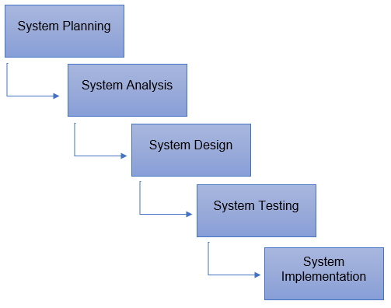

*Figure 4.2: Project Development Process*

**System Planning and Analysis.**

In this phase, the proponents gathered data that needed in their systems like software requirements, hardware requirements and the idea in terms of e-commerce. They analyzed the solution of the gathered data of the proposed system. Before the proponents start the actual coding, they need to understand the requirements of the client-side design and user, and the finished product looks like.

**System Design**

After the planning and analyzing part, the design helps in indicating software and hardware requirements, and it helps the overall system planning. The proponents study an UI/UX for the better graphical user interface. They create an algorithm to make Management System for Food E-Commerce with PayPal Integration and Database Algorithm run faster in different web browser.

**System Testing and Implementation**

The work split in different modules and the actual coding must start. The small part is called modules, modules are tested and developed for its functionality. And integrated all modules to the implementation. The proponents test their system in hard ways like security, files accessing, a bunch of data, simultaneously use of website, text field expression and image upload. And in the implementation, they upload the website and template to the web server. They make their website more accessible.

**Flowchart**

The flowchart below illustrates the sequential order of a process needed to perform by the proponents. Each step in the sequential order is recognized within diagram shape. Sequential order is associated with connecting lines with directional arrows. This allows everyone to prospect the entire flowchart of the proposed system.



*Figure 4.3: Flowchart*



*Figure 4.4: Flowchart*



*Figure 4.5: Flowchart*



*Figure 4.6: Flowchart*



*Figure 4.7: Flowchart*



*Figure 4.8: Flowchart*



*Figure 4.9: Flowchart*



*Figure 4.10: Flowchart*



*Figure 4.11: Flowchart*



*Figure 4.12: Flowchart*



*Figure 4.13: Flowchart*



*Figure 4.14: Flowchart*



*Figure 4.15: Flowchart*



*Figure 4.16: Flowchart*



*Figure 4.17: Flowchart*



*Figure 4.18: Flowchart*



*Figure 4.19: Flowchart*



*Figure 4.20: Flowchart*



*Figure 4.21: Flowchart*



*Figure 4.22: Flowchart*

**4.2 Project Structure**

**HIPO Chart (Hierarchy plus Input-Process-Output)**

The illustrations below show the entire blueprint of the system including the hierarchy chart that strongly represents the system’s control structure and screenshots of every page of the website.



*Figure 4.23: HIPO (Hierarchy plus Input-Process-Output)*



*Figure 4.24: HIPO (Hierarchy plus Input-Process-Output)*



*Figure 4.25: HIPO (Hierarchy plus Input-Process-Output)*



*Figure 4.26: HIPO (Hierarchy plus Input-Process-Output)*



*Figure 4.27: HIPO (Hierarchy plus Input-Process-Output)*



*Figure 4.28: HIPO (Hierarchy plus Input-Process-Output)*



*Figure 4.29: HIPO (Hierarchy plus Input-Process-Output)*



*Figure 4.30: HIPO (Hierarchy plus Input-Process-Output)*



*Figure 4.31: HIPO (Hierarchy plus Input-Process-Output)*



*Figure 4.32: HIPO Chart (Hierarchy plus Input-Process-Output)*

**Screenshots**

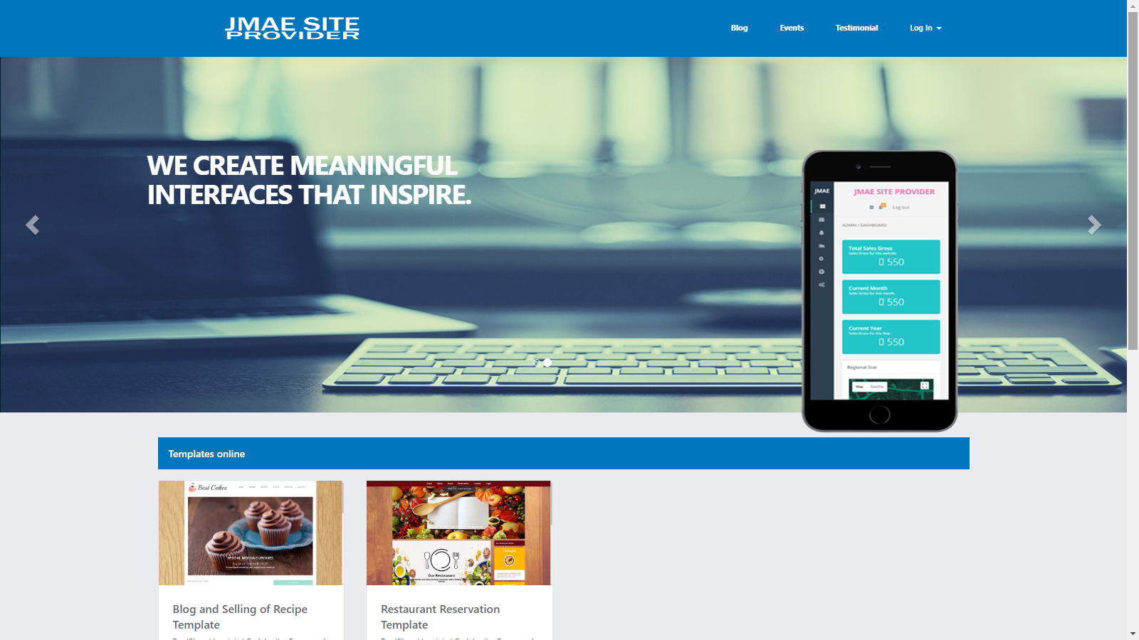

*Figure 4.33: Home*

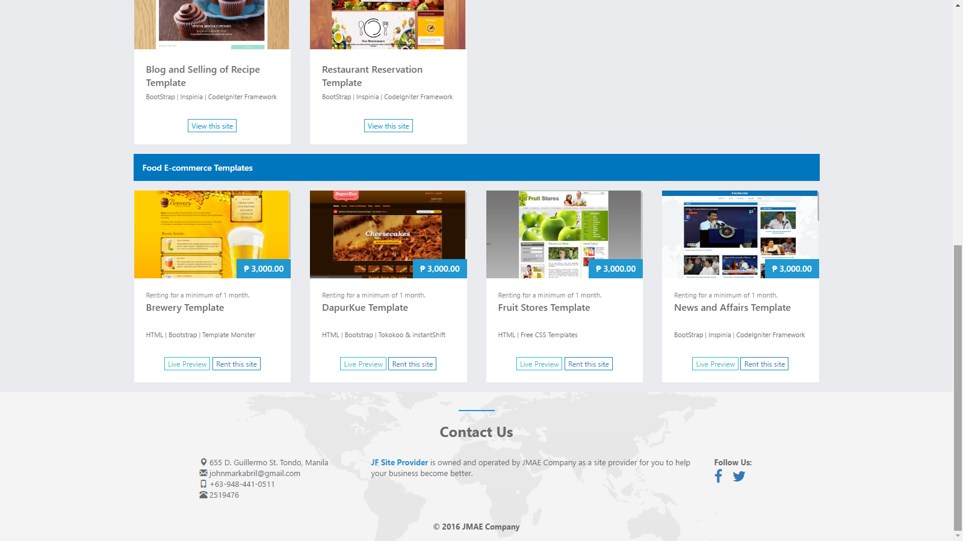

*Figure 4.34: Home*

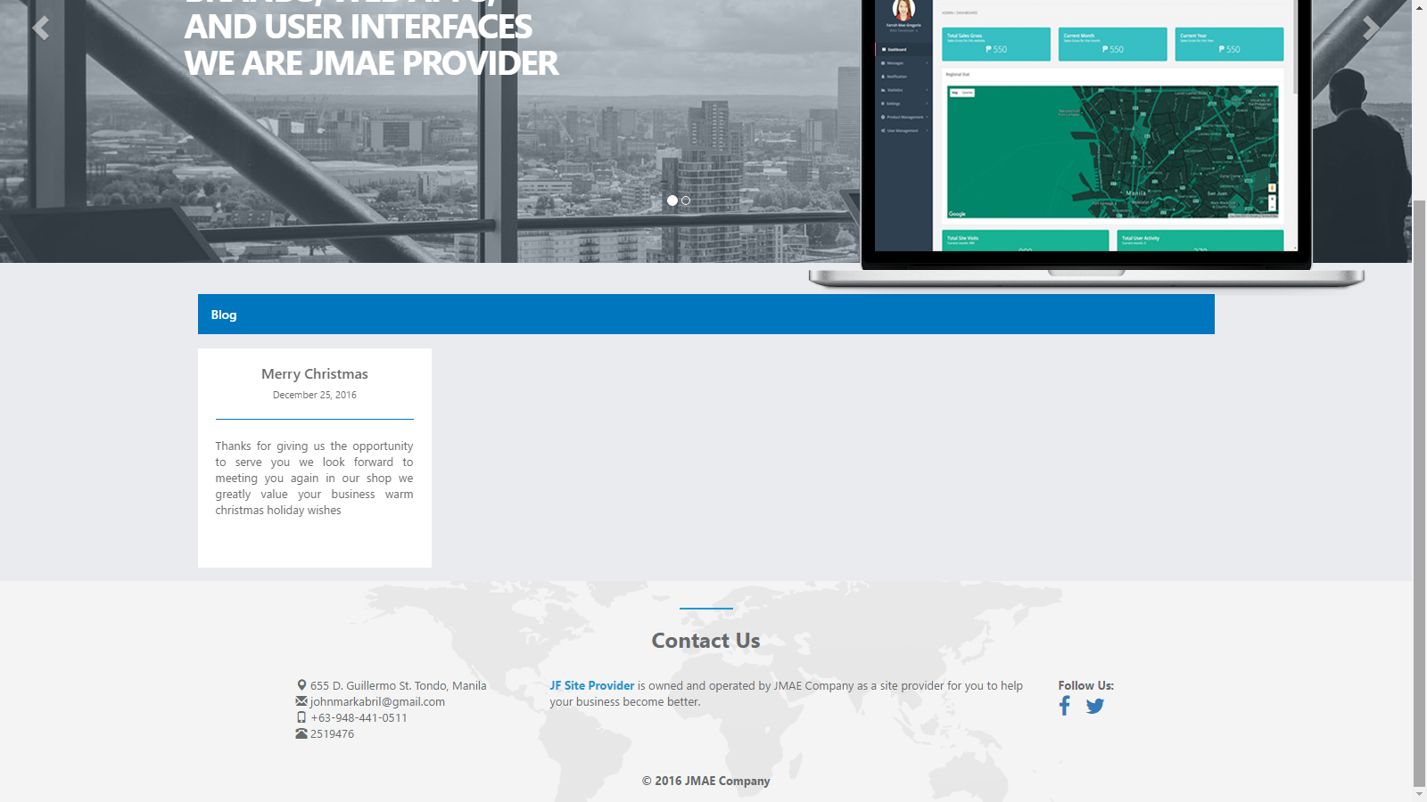

*Figure 4.35: Blog – User*

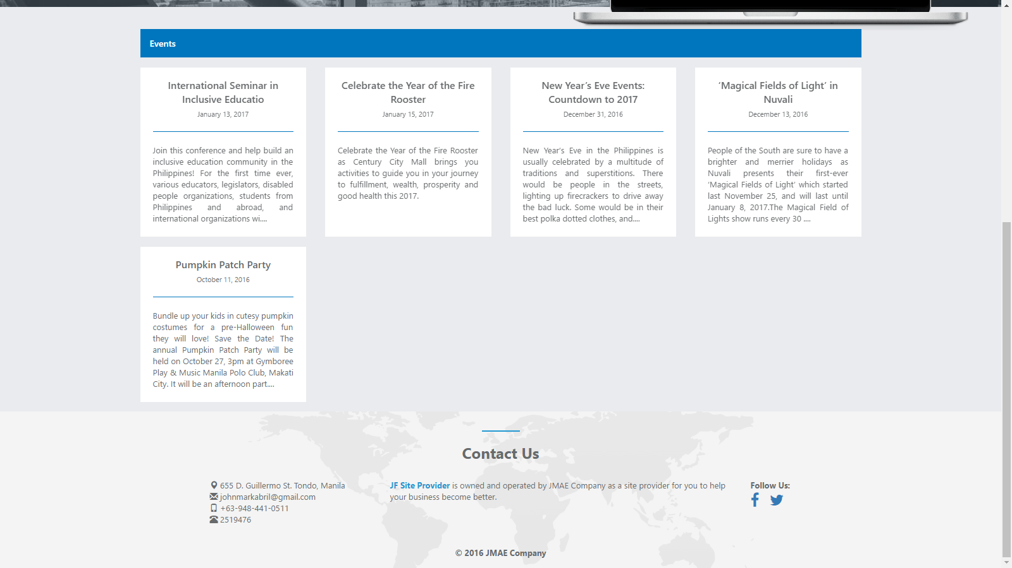

*Figure 4.36: Events - User*

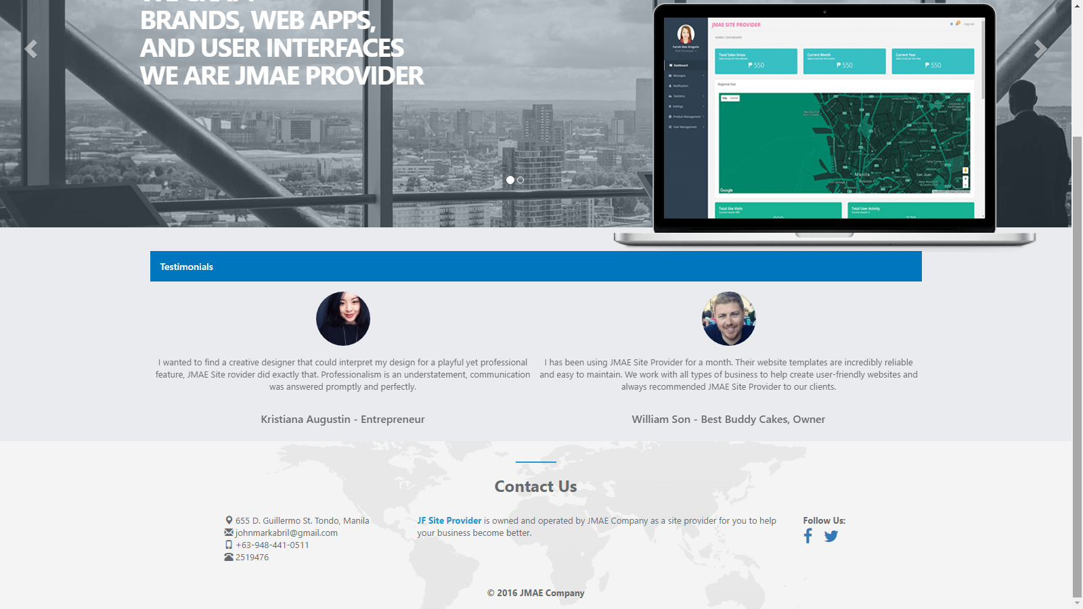

*Figure 4.37: Testimonials - User*

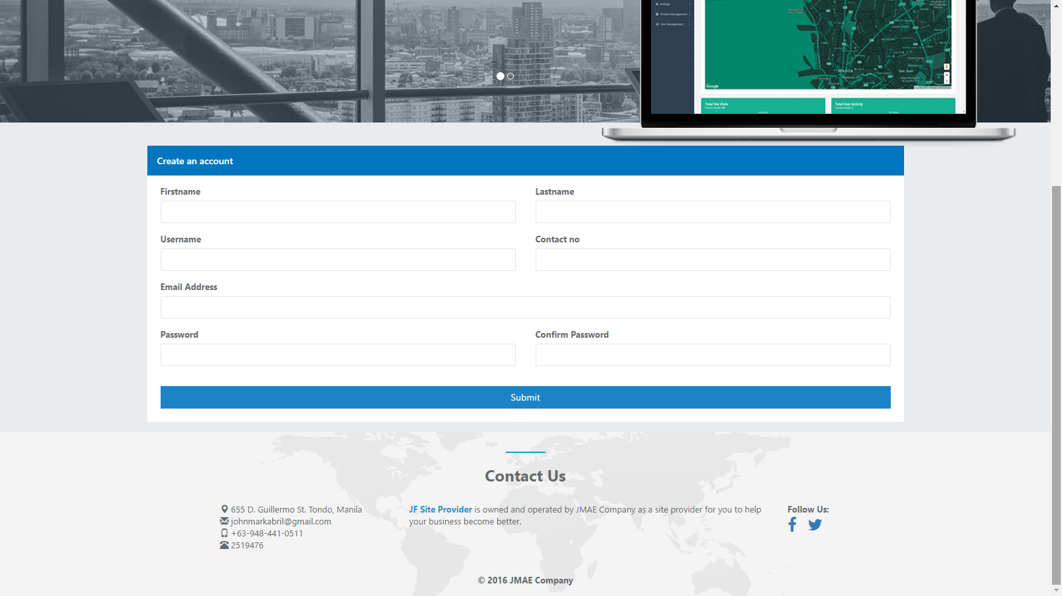

*Figure 4.38: Create an account - User*

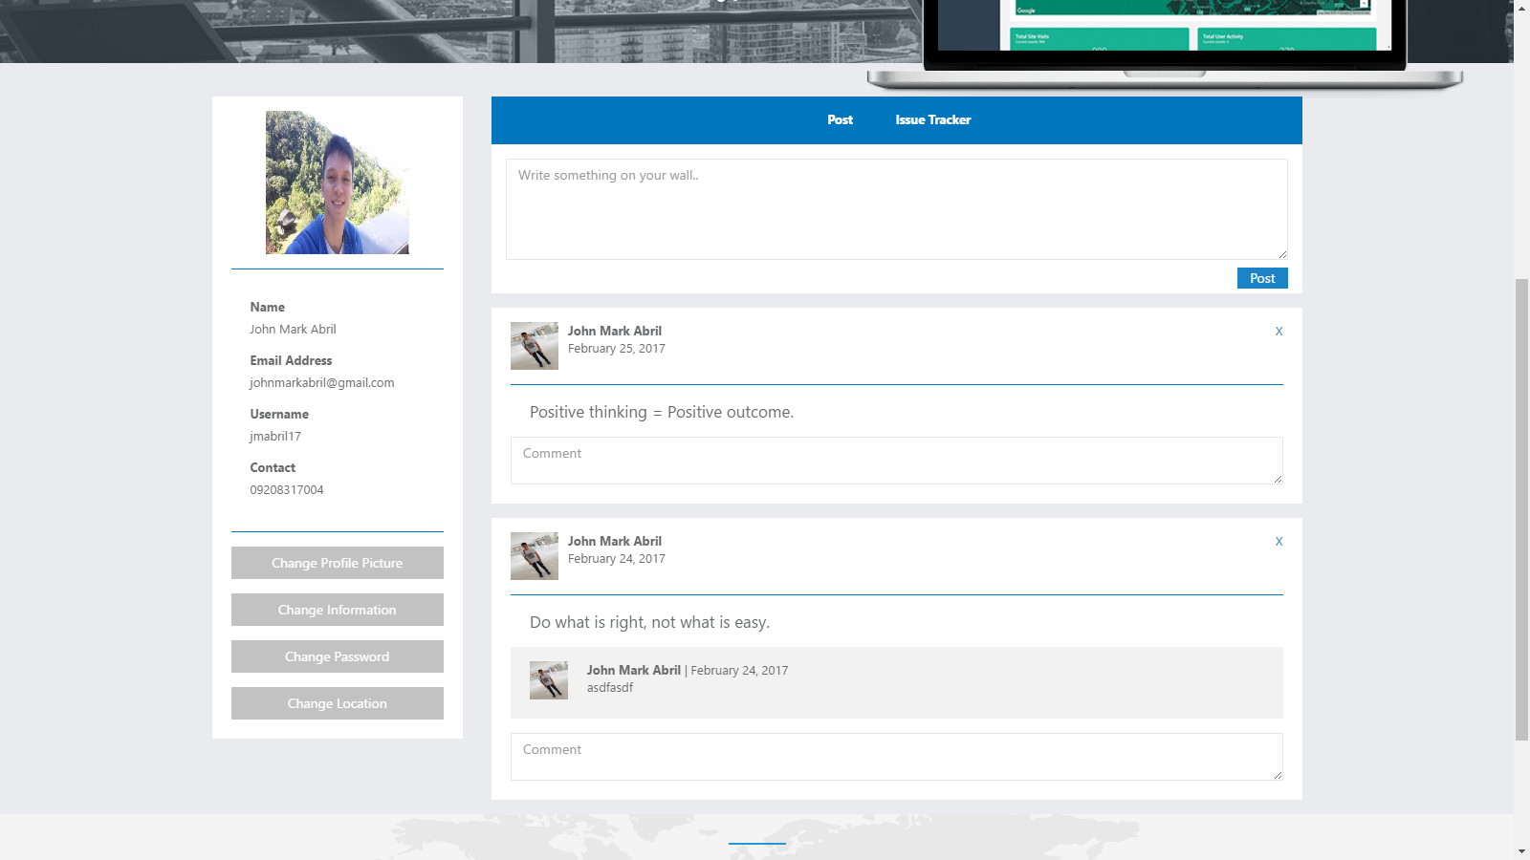

*Figure 4.39: Profile – Post - User*

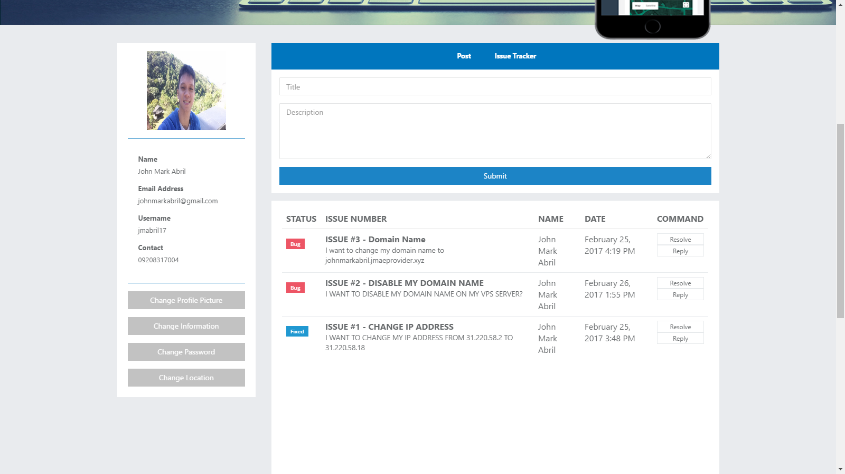

*Figure 4.40: Profile – Issue Tracker - User*

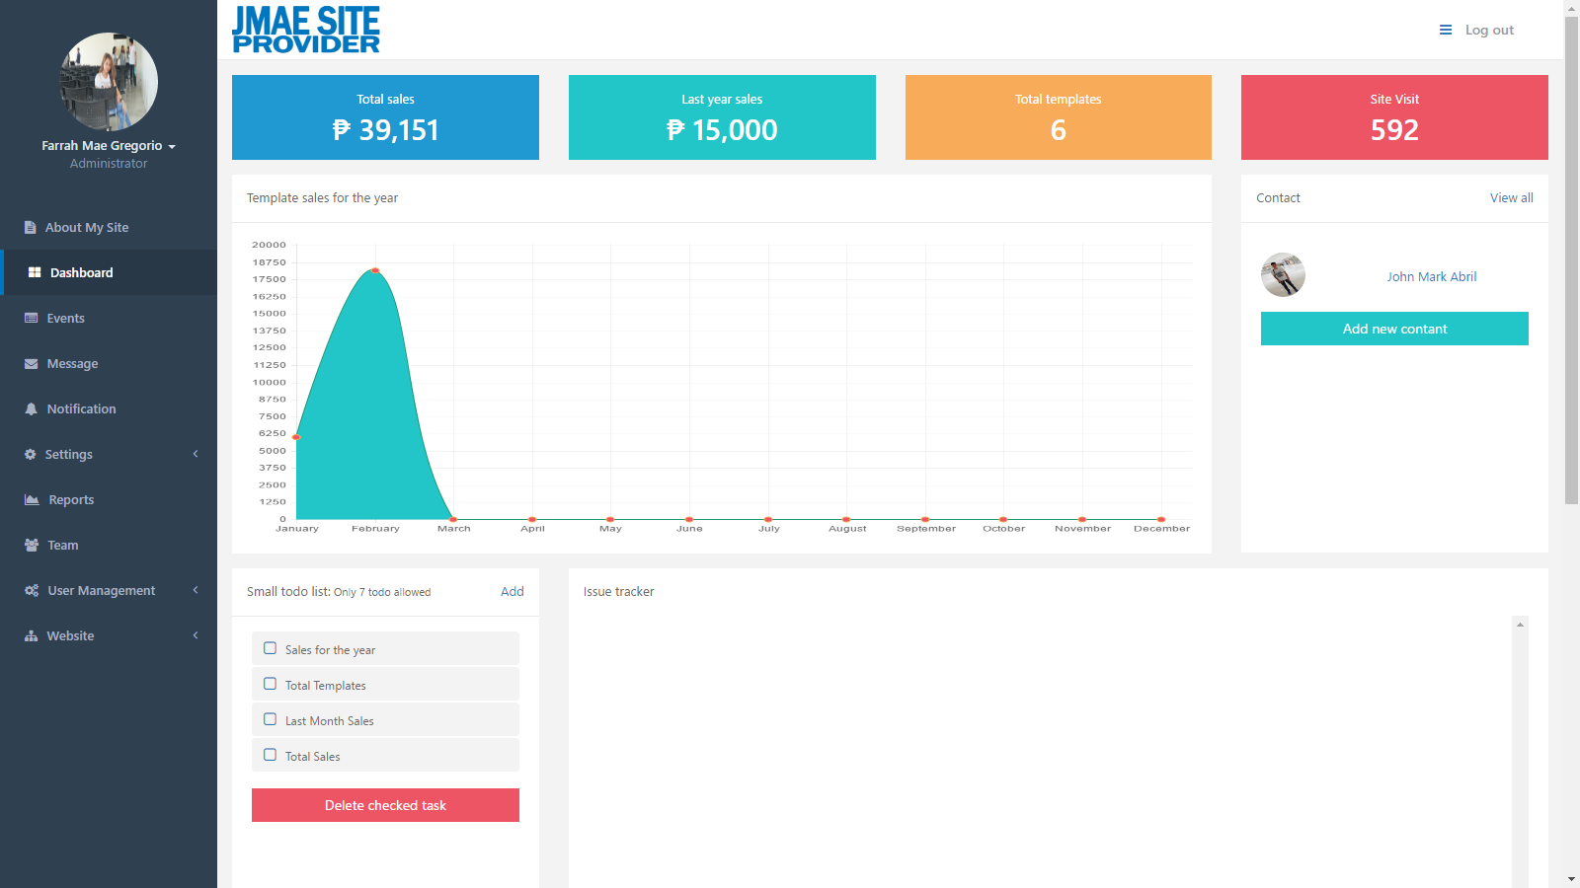

*Figure 4.41: Dashboard - Administrator*

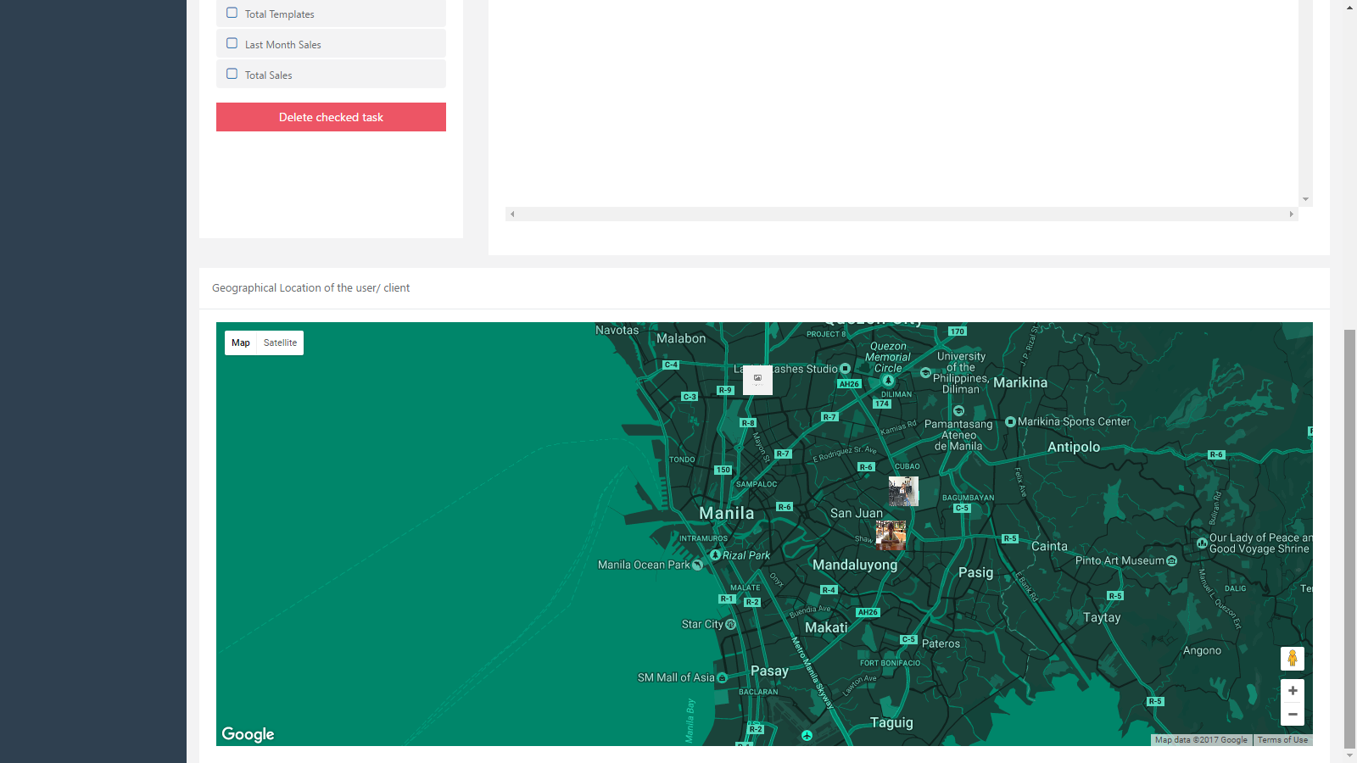

*Figure 4.42: Dashboard - Administrator*

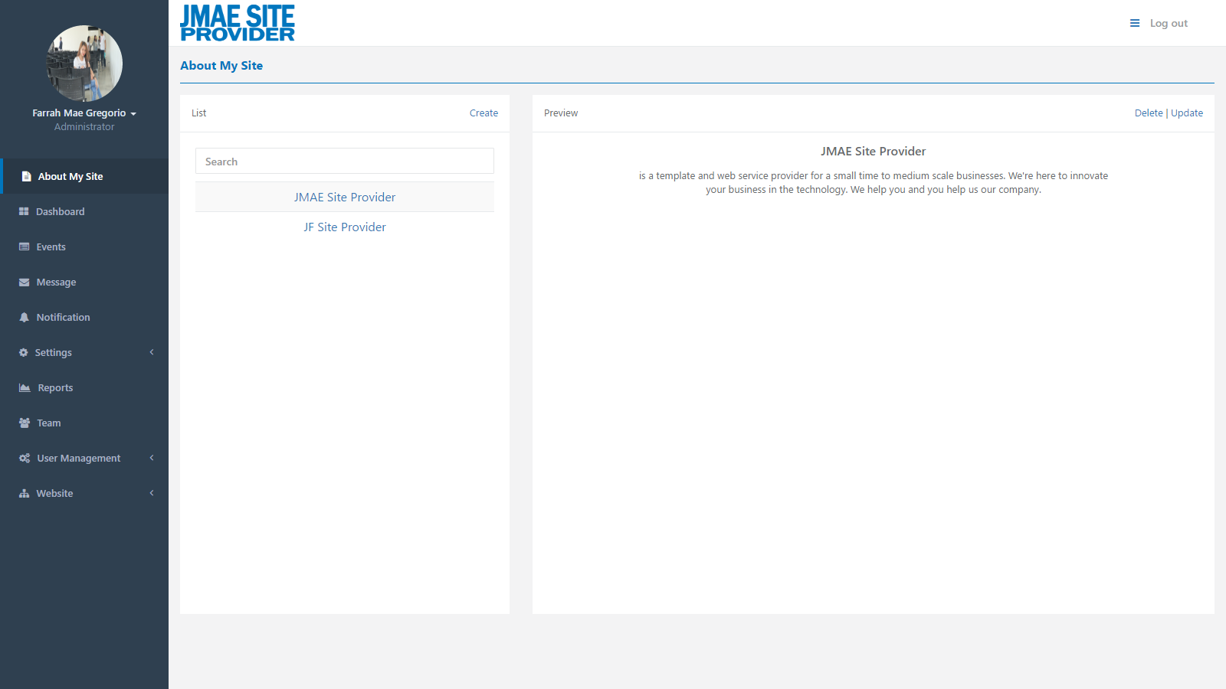

*Figure 4.43: About my site - Administrator*

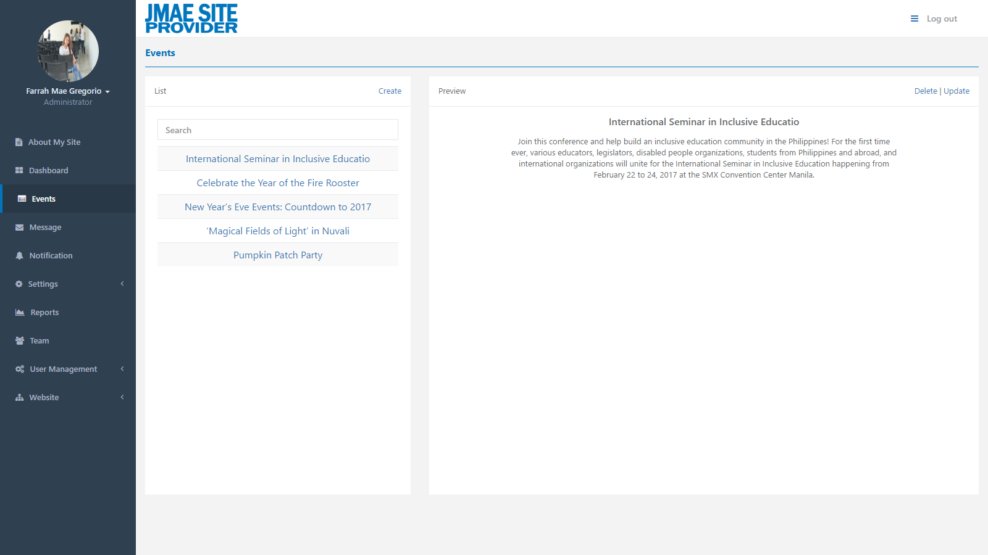

*Figure 4.44: Events - Administrator*

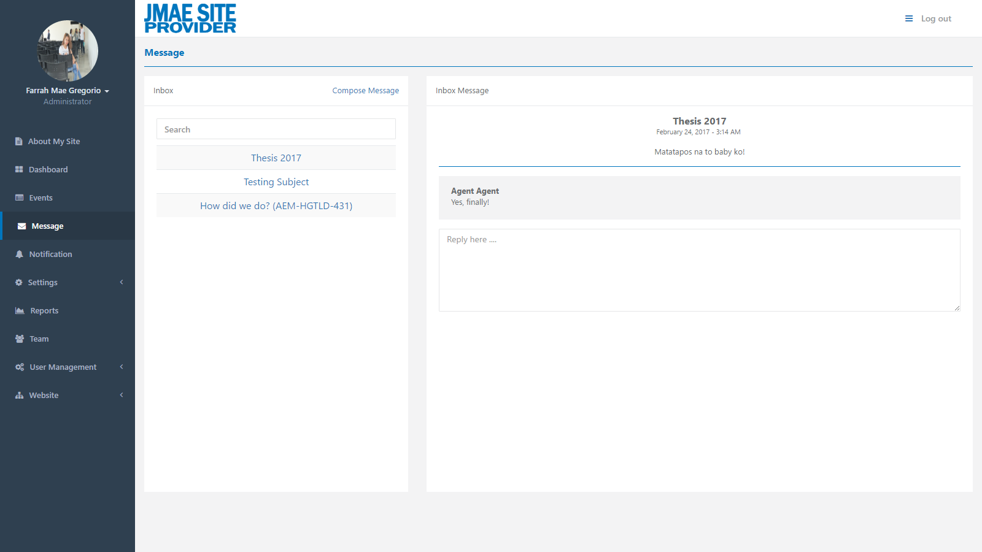

*Figure 4.45: Message - Administrator*

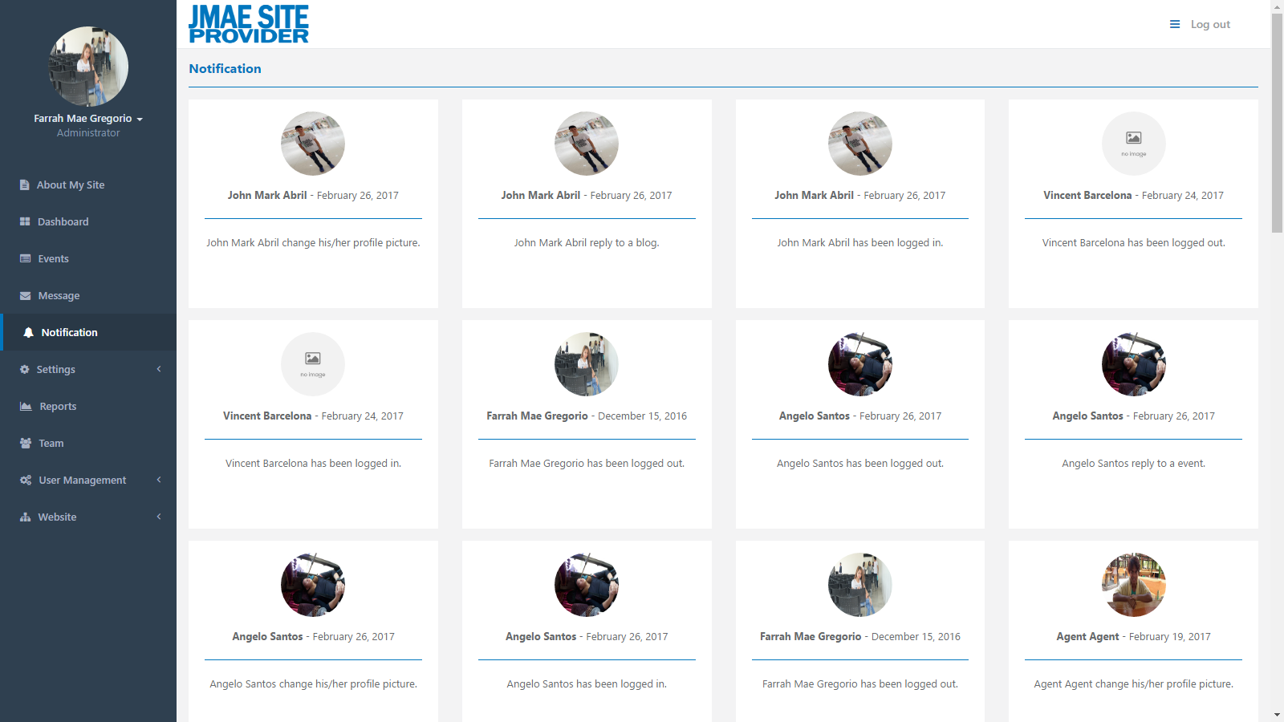

*Figure 4.46: Notification - Administrator*

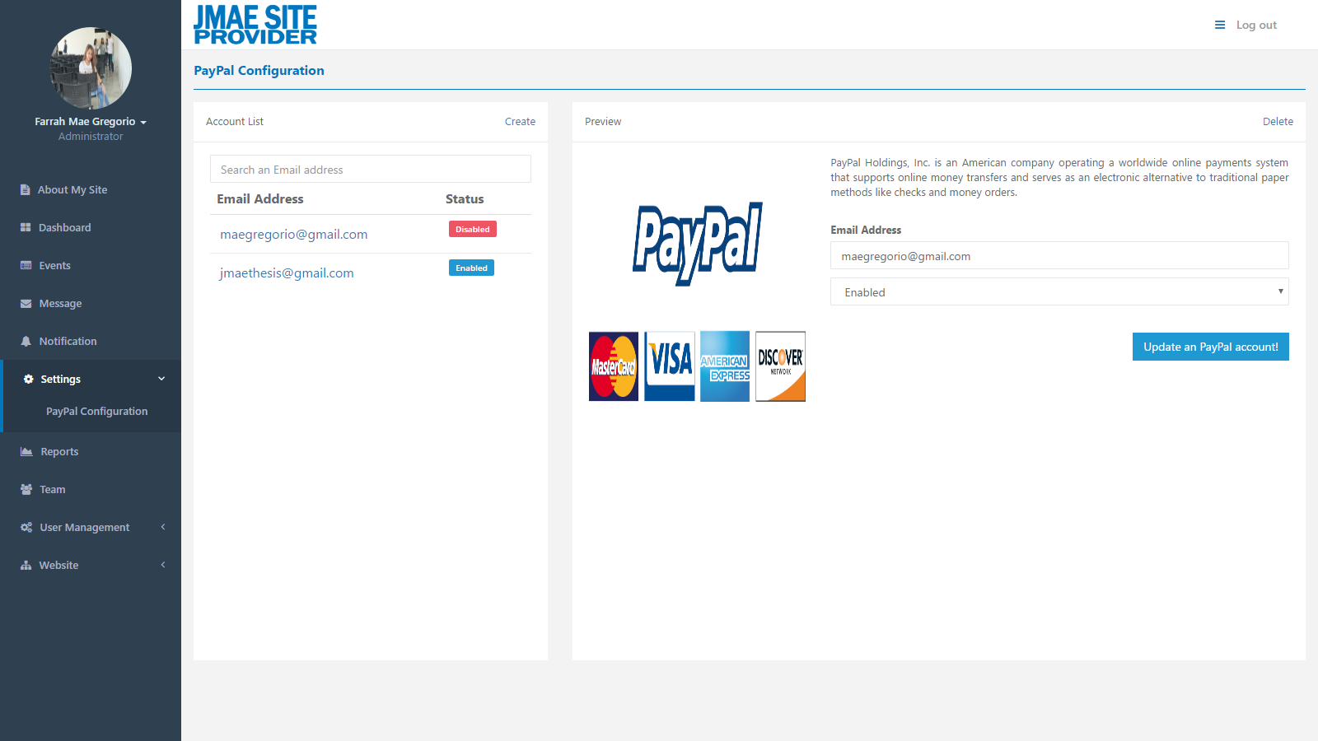

*Figure 4.47: PayPal Configuration - Administrator*

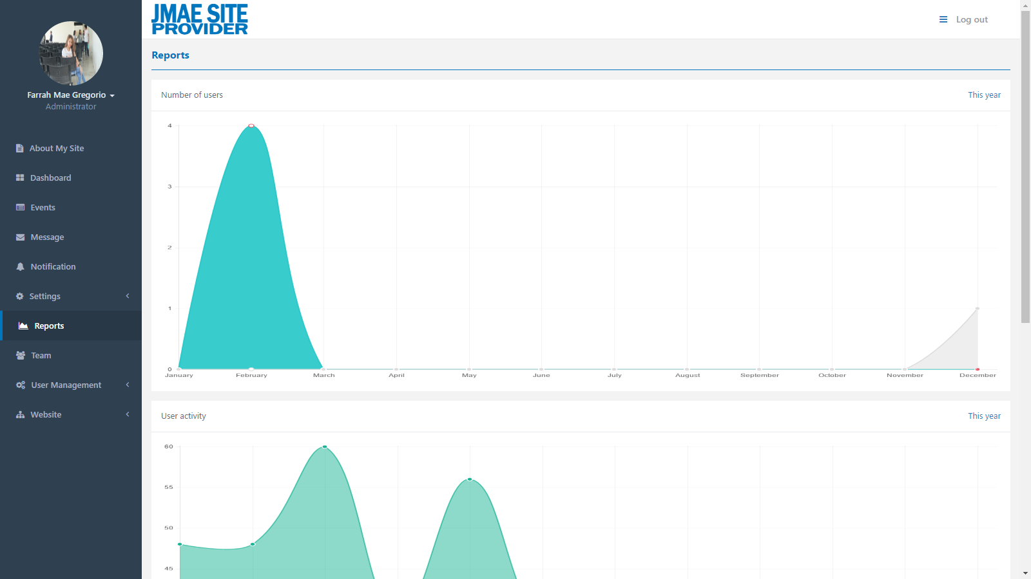

*Figure 4.48: Reports - Administrator*

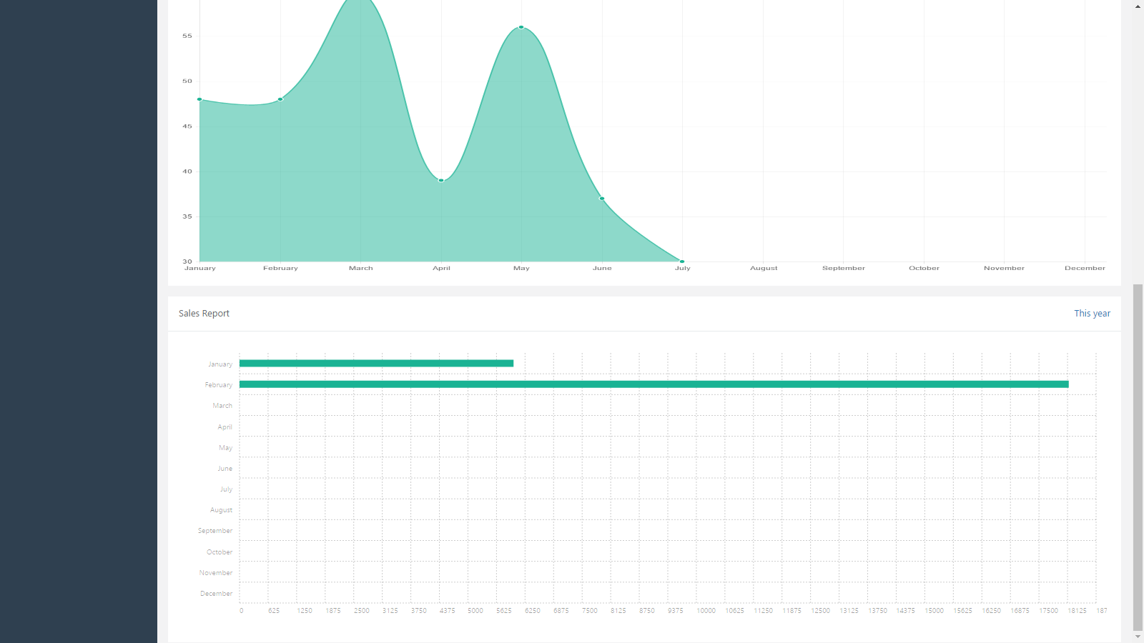

*Figure 4.49: Reports - Administrator*

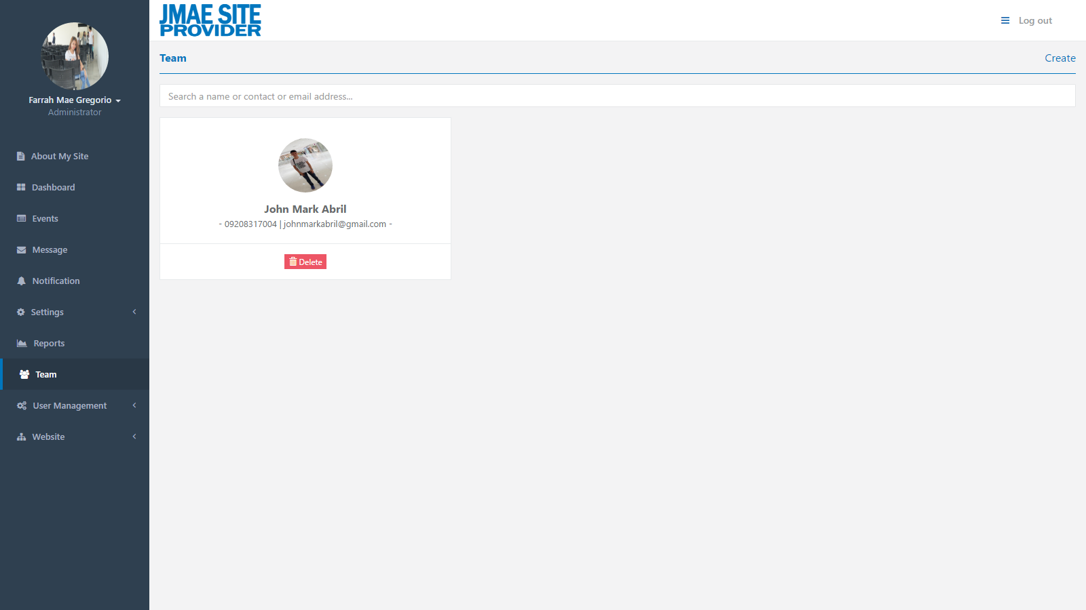

*Figure 4.50: Team - Administrator*

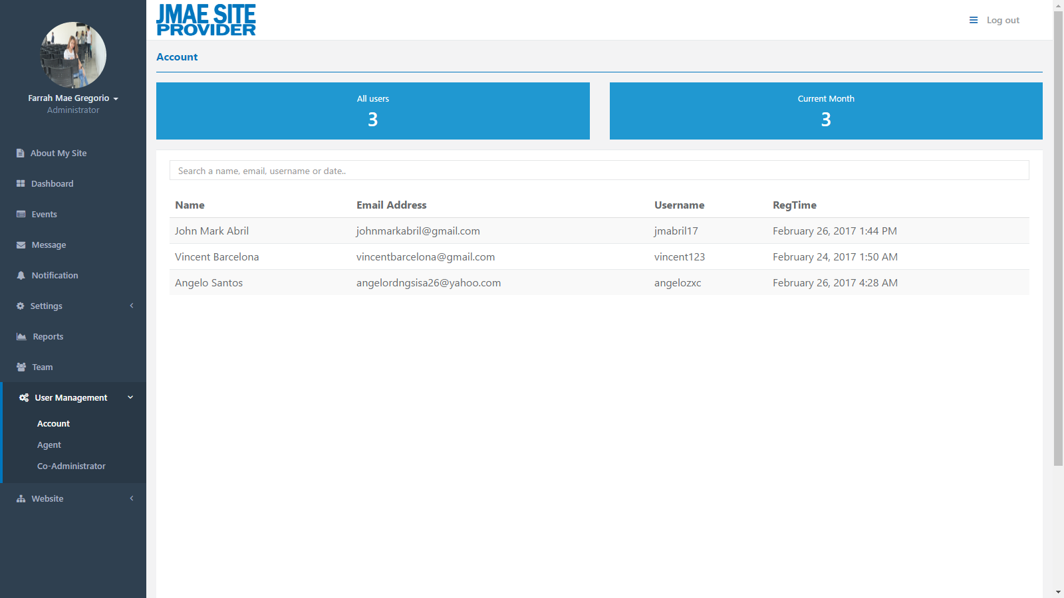

*Figure 4.51: Account - Administrator*

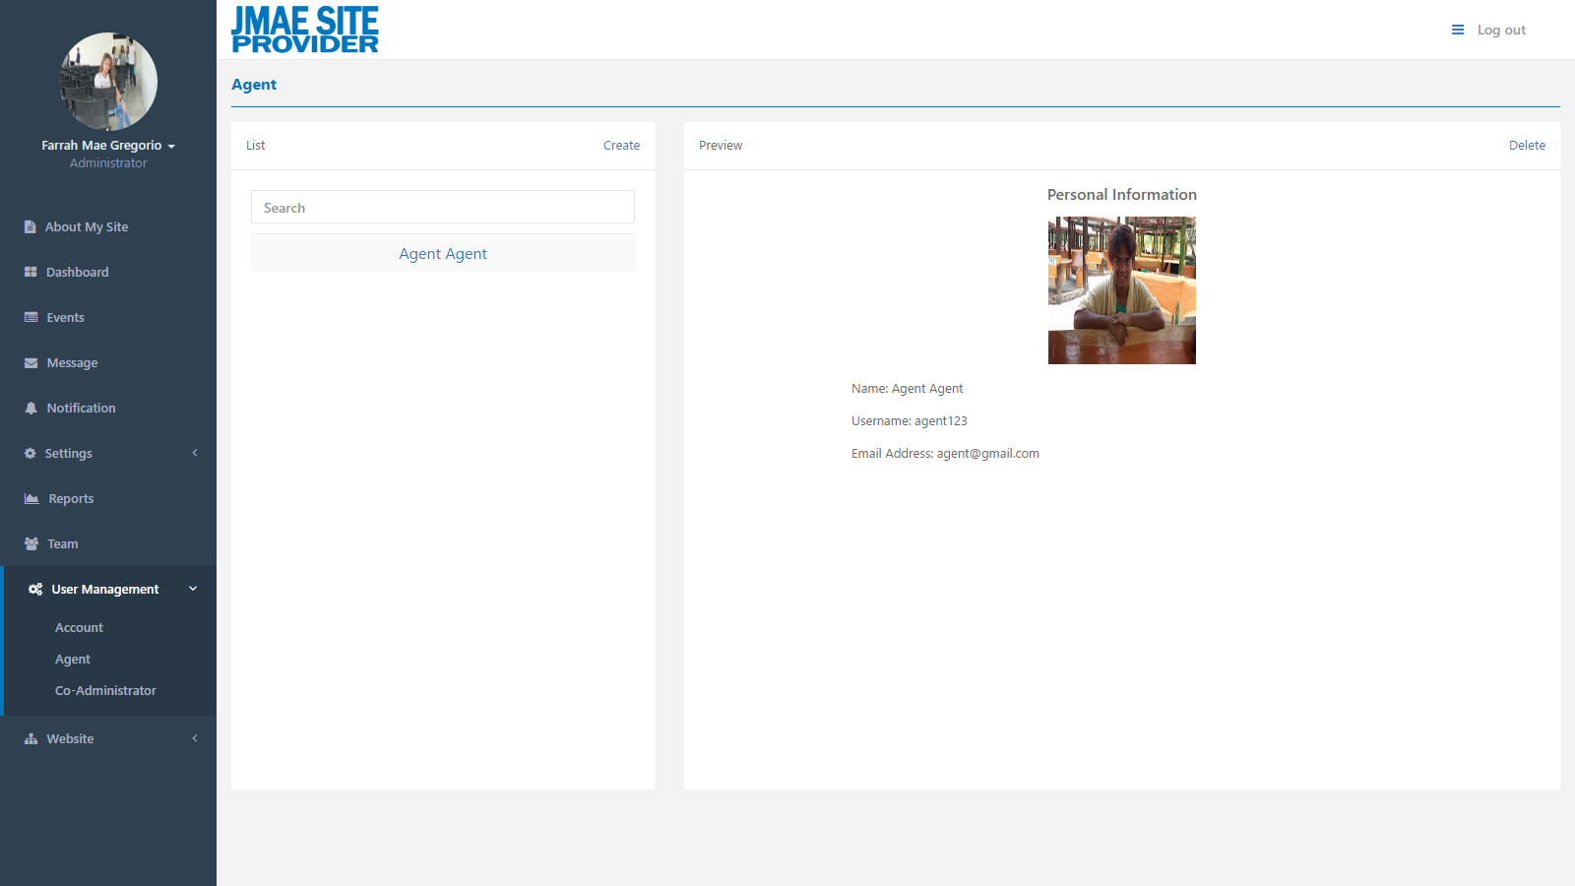

*Figure 4.52: Agent - Administrator*

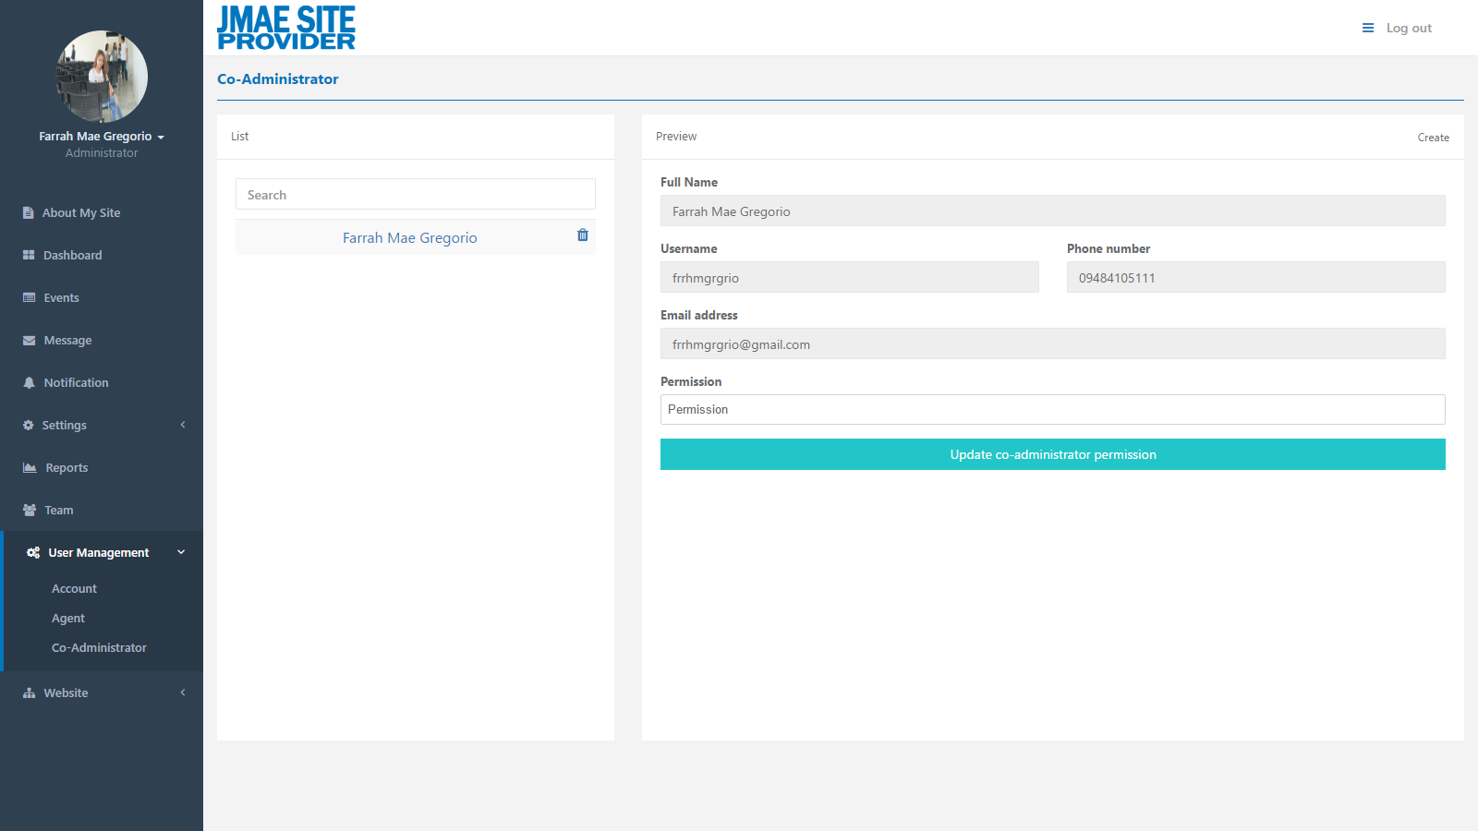

*Figure 4.53: Co-Administrator - Administrator*

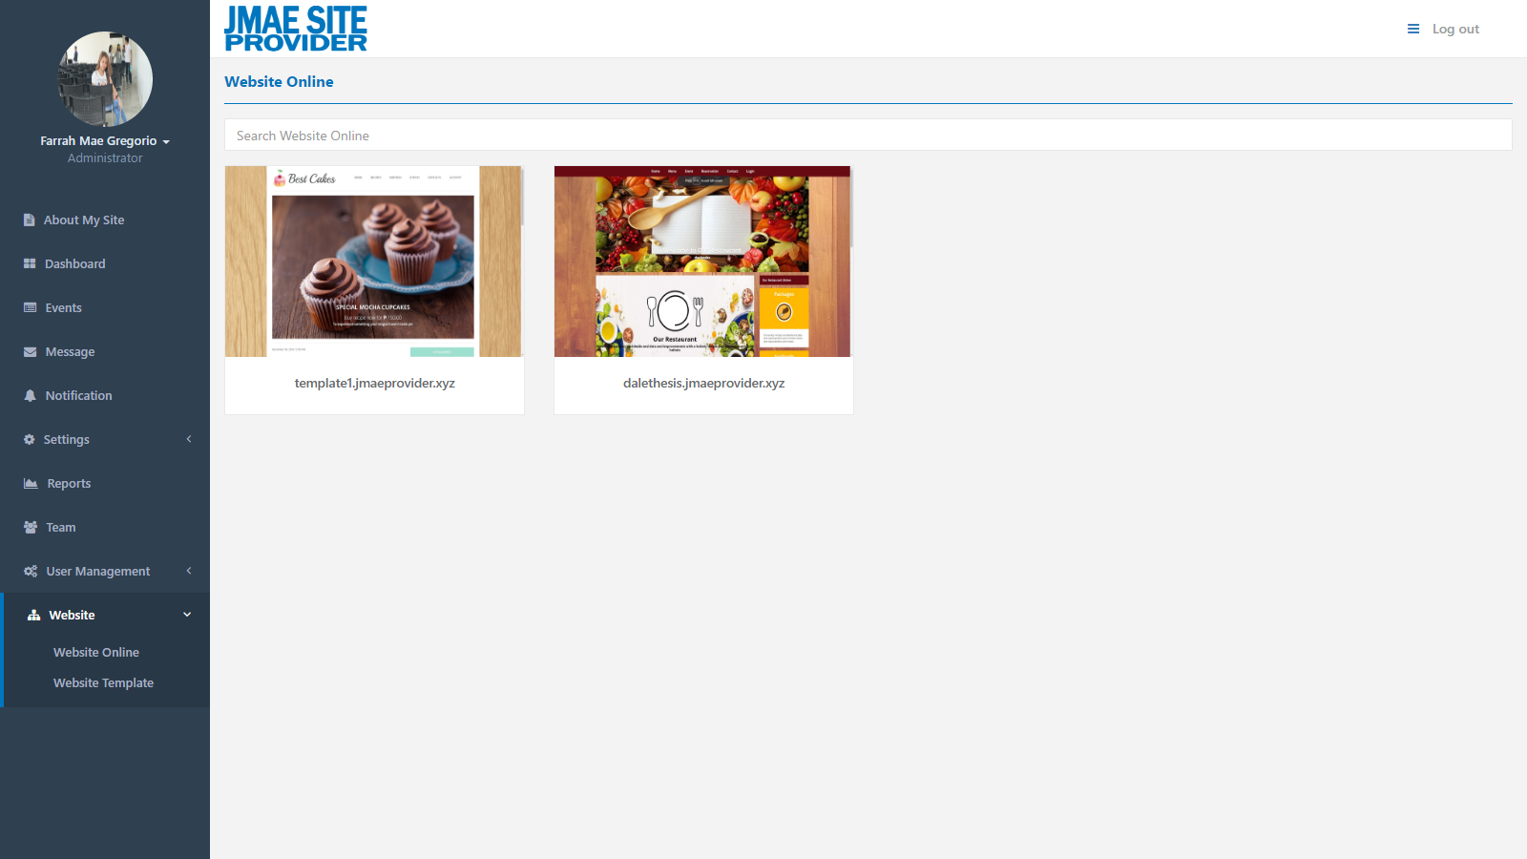

*Figure 4.54: Website Online - Administrator*

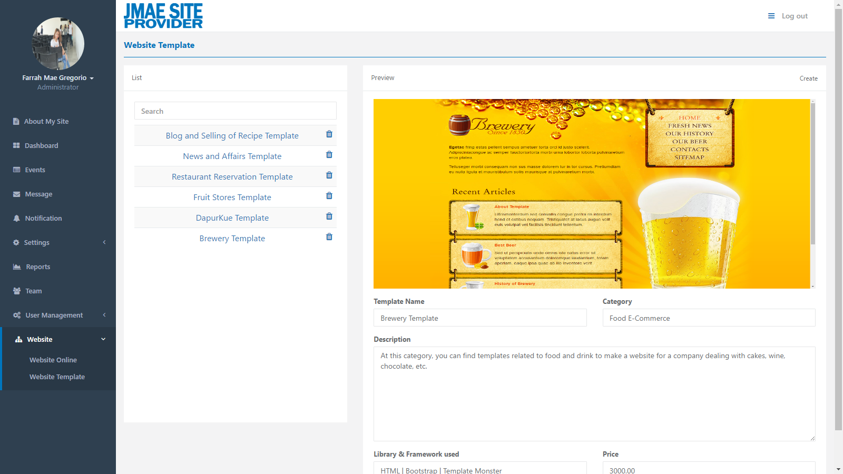

*Figure 4.55: Website Template - Administrator*

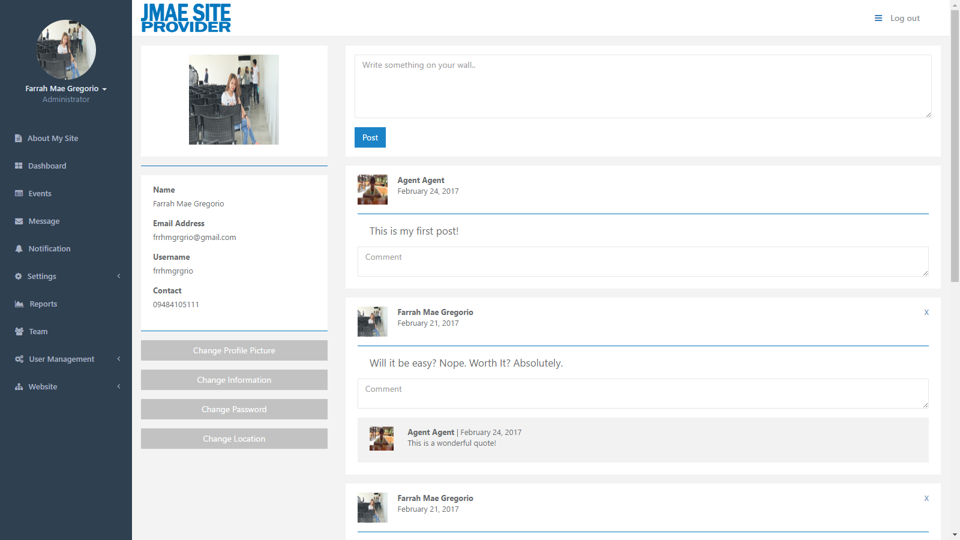

*Figure 4.56: Profile - Administrator*

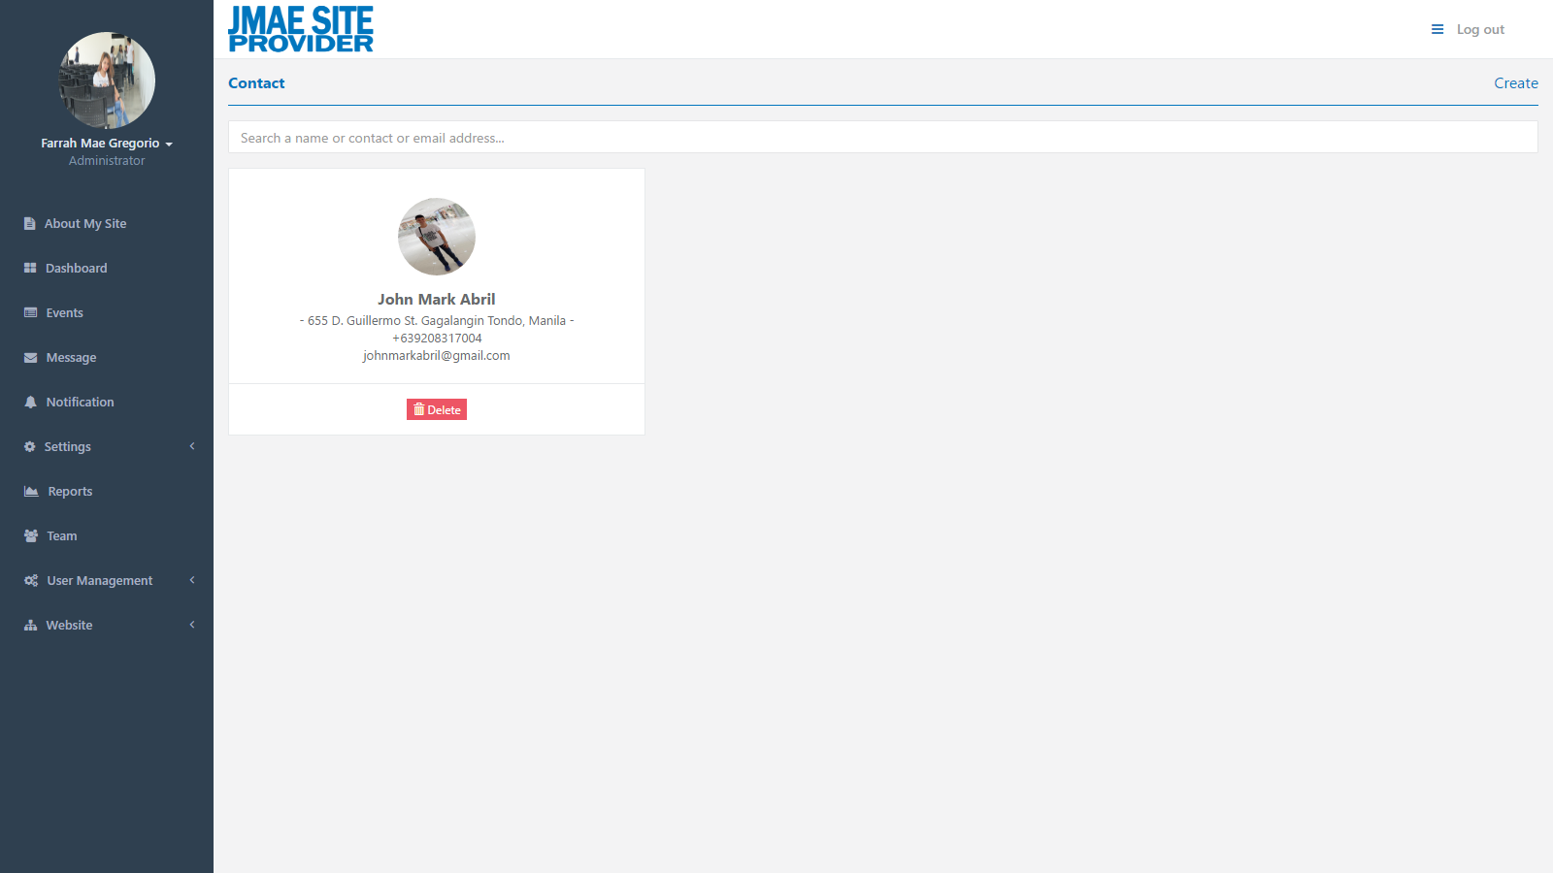

*Figure 4.57: Contact - Administrator*

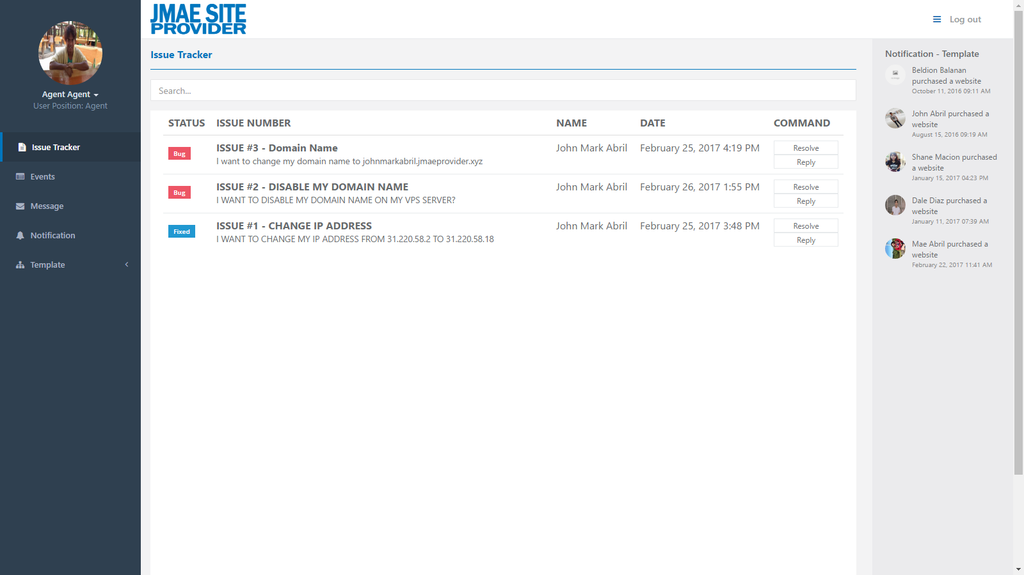

*Figure 4.58: Issue tracker - Agent*

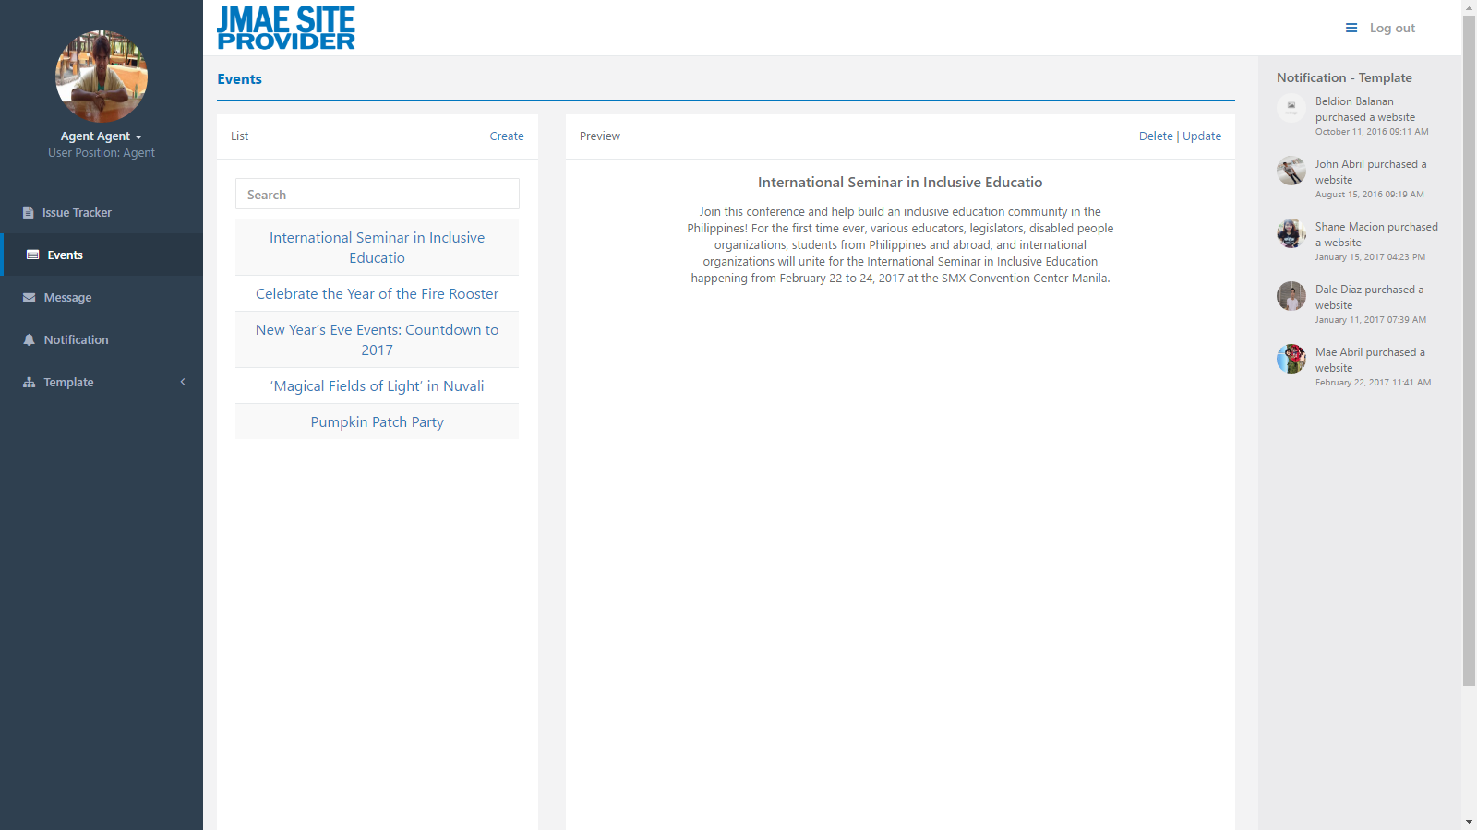

*Figure 4.59: Events - Agent*

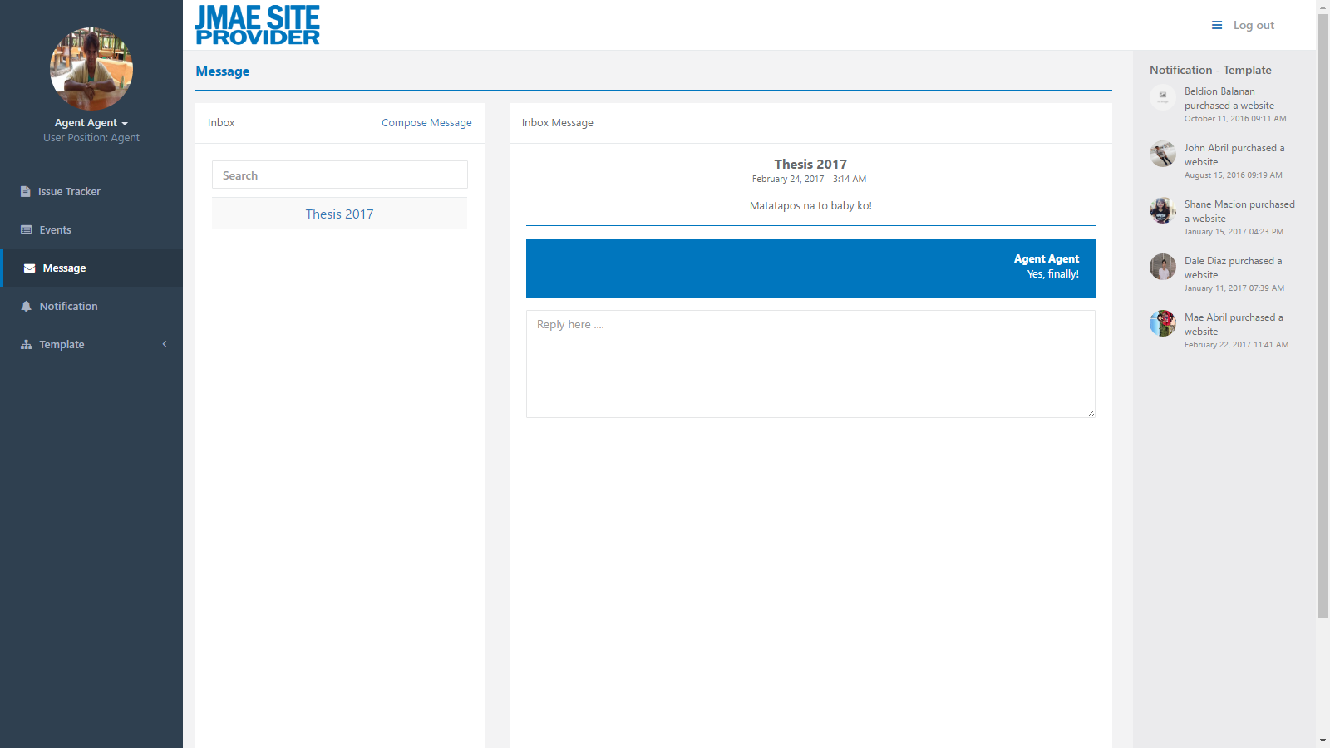

*Figure 4.60: Message - Agent*

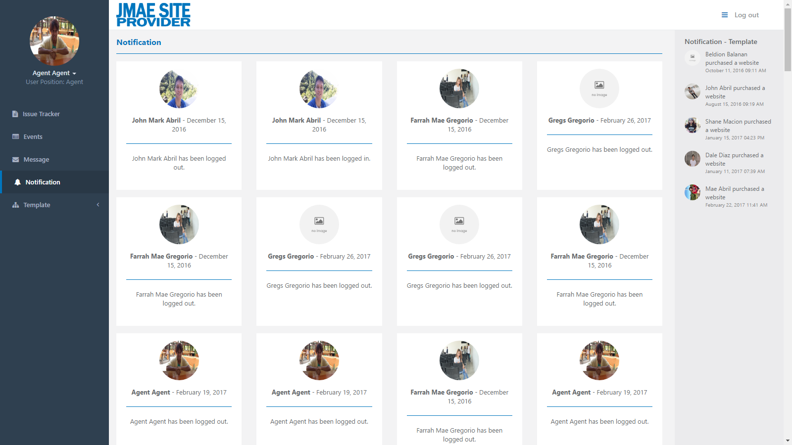

*Figure 4.61: Notification - Agent*

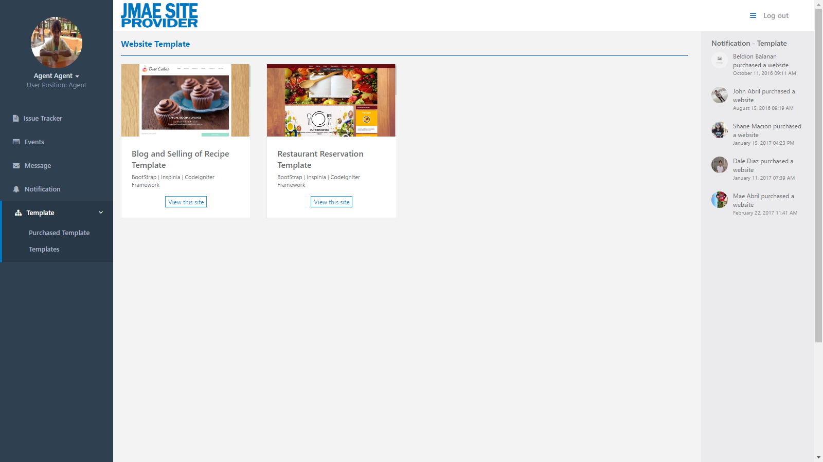

*Figure 4.62: Purchased Template - Agent*

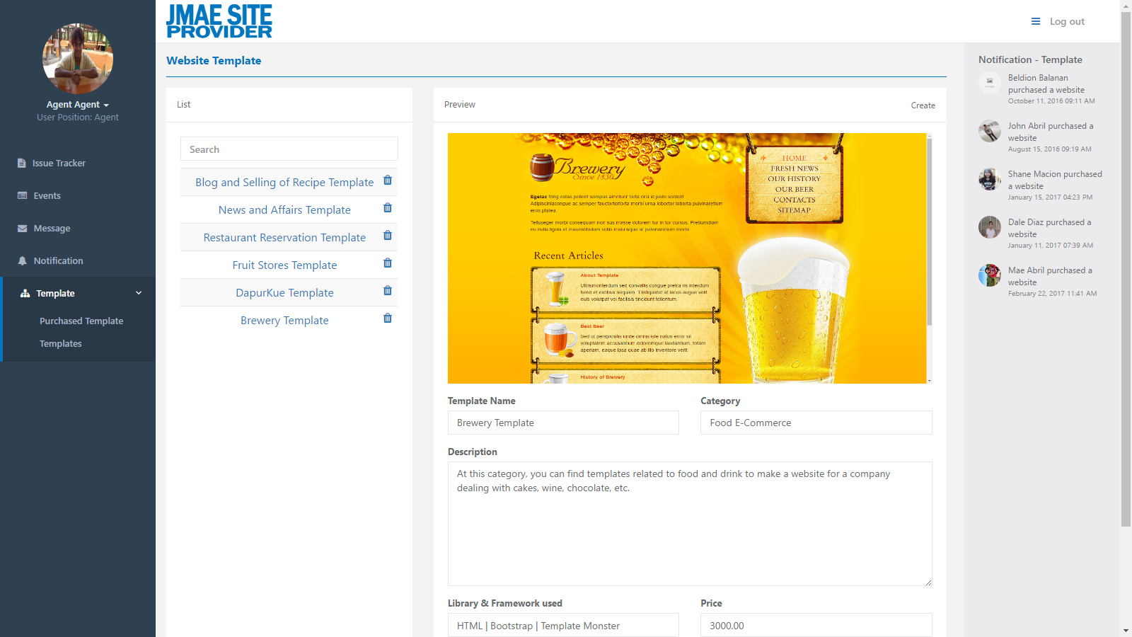

*Figure 4.63: Template - Agent*

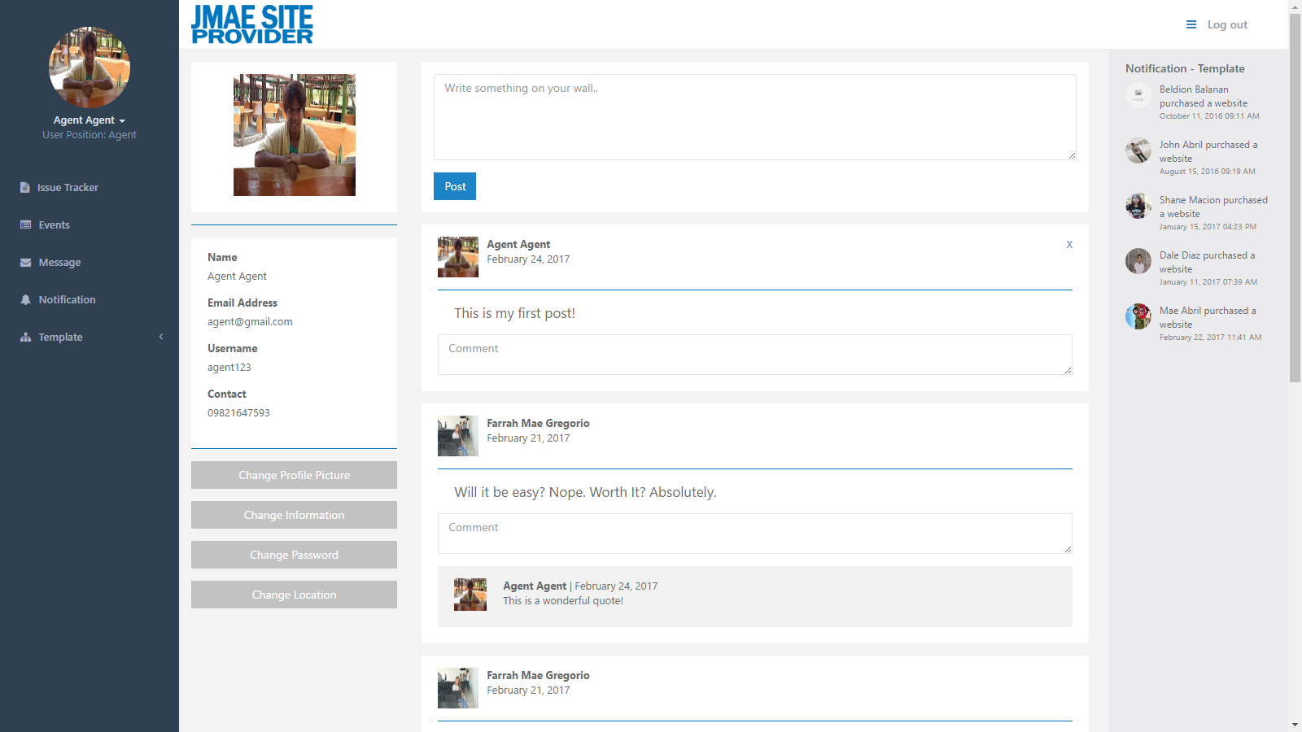

*Figure 4.64: Profile - Agent*

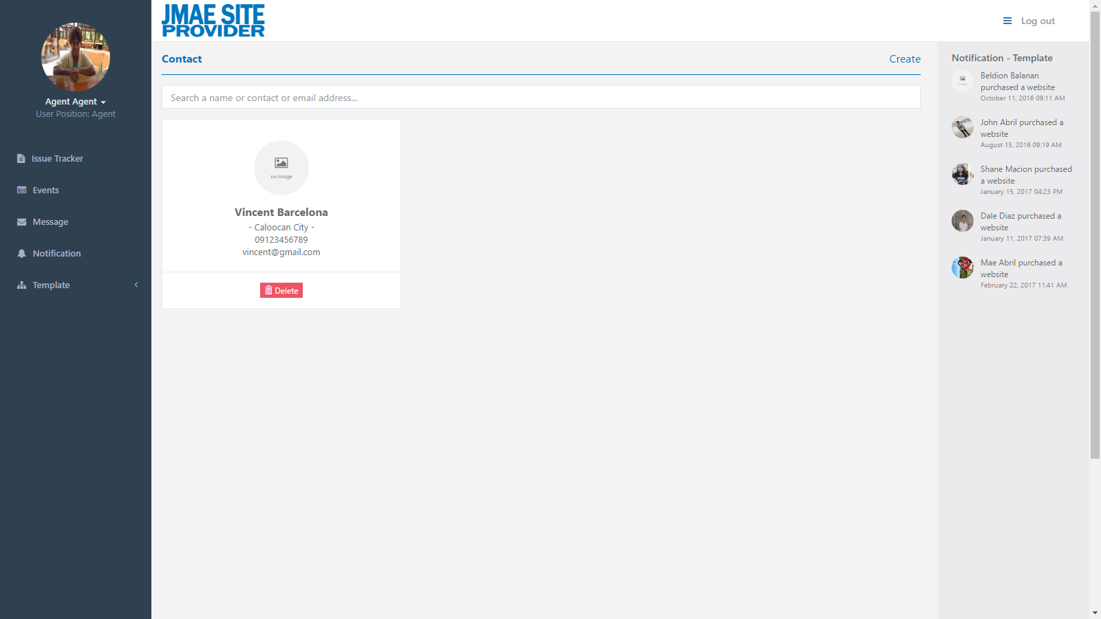

*Figure 4.65: Contact - Agent*

**4.3 Tabulating Results from the Proposed System**

**Project Evaluation**

The result of the respondent’s feedback to a given questions.

Tabular Presentation

|  |  |  |  |
| --- | --- | --- | --- |
| **No. of Respondents** | **Businessman and businesswoman** | **Future Customers** | **Programmer or developer** |
| 40 | 20 | 10 | 10 |

Table I. Shows the number of respondents and their position

1. The validity of every text field is accurate?

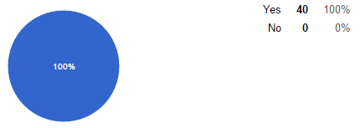

All the respondents are agreeing that the text field is accurate.

1. Did you prefer PayPal as a payment procedure?

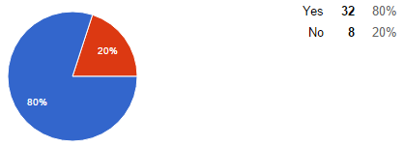

The 80% of the respondents are preferred of using PayPal as a payment method.

1. Does the e-commerce website is good for small to medium scale business operation?

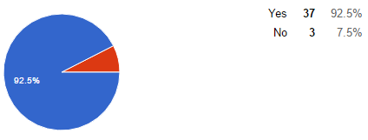

The 92.5% of respondents have agreed that the e-commerce is good for small to medium scale business operation.

1. For what purpose do you use e-commerce website?

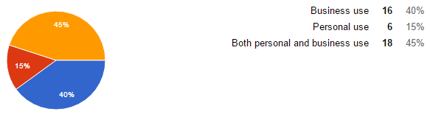

The 40% of respondents have said that the e-commerce website is good for business use. While the other 15% of respondents are chosen a personal user and the other 45% of respondents are said that the e-commerce website is good for both business and personal use.

1. According to you how e-commerce is helpful for the business?

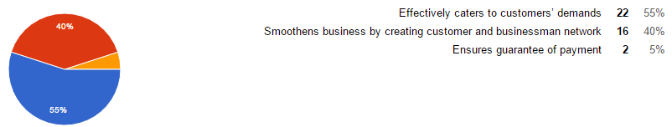

The 55% of respondents said that the e-commerce is helpful in terms of effectively caters to customers’ demands. While the 40% of respondents are in favor in terms of smoothens business by creating customer and business network. And the other 5% are in favor of ensures the guarantee of payment.

1. Why do you prefer online purchasing (choose as many as applicable)?

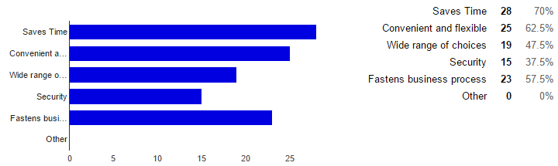

The most of the respondents said that the online purchasing can save time and convenient and flexible.

1. Rate e-commerce website from what you have seen and your experience with our sites in terms of Visual appearance/layout.

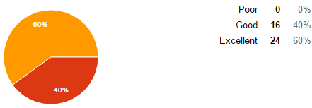

The 60% of respondents said that our website is excellent in terms of visual appearance or layout.

1. Rate e-commerce website from what you have seen and your experience with our sites in terms of Content.

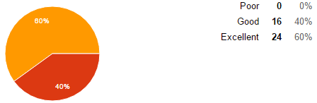

The 60% of respondents said that our website is excellent in terms of the content.

1. E-commerce website responds quickly to email queries?

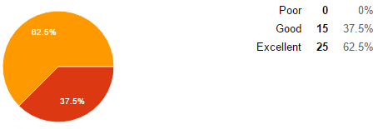

The 62.5% of respondents said that our website is excellent in terms of the response quickly to e-mail queries.

1. E-commerce website has improved customer service?

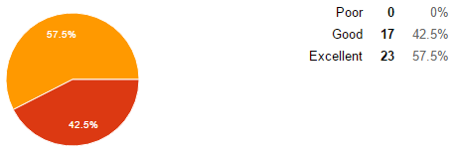

The 57.5% of respondents said that our website is excellent in terms of customer service.